Long Distance Tracking and Monitoring with LoRa
Stuart Robinson
27th April 2016
Part 6 – Testing and Comparing

Many things can affect the performance of a radio link, the location, how far apart the transmitter and receiver are, the way the modules are constructed, battery levels, type of antennas and whether the modules have been damaged or not. At the low power levels used by the LoRa modules, typically 10mW or less, many constructors will not have test equipment capable of measuring such low powers. A similar problem exists for tuning antennas, SWR meters capable of operating at these low powers are not common.

The LoRa modules are capable of measuring the level of signals or noise seen at their antenna input and of carrying out measurements of signal level and noise during packet reception. These measurements may not be to laboratory standard accuracy wise, but they do allow comparative tests to be made. Often a comparative test is sufficient and you can tune an antenna for maximum signal output using a crude signal level meter.

A benchmark test that can be used to check the performance of a pair of 433Mhz LoRa modules or their antennas would also be useful. If its known what the RSSI (signal strength) indication is for a LoRa receiver under a controlled set of test conditions, its possible to establish if a transmitter and receiver pair is working as expected.

A LoRa receiver can be used as a signal strength meter if a LoRa transmitter is used to send data packets. As long as the receiver is at a consistent distance and position in relation to the transmitter, then differences in effectiveness of antennas on the transmitter and receiver will be seen as differences in signal level at the receiver. Also note that the relative differences in received signal strength should equate to relative differences in transmitter or receiver antenna performance. If with a particular antenna the received signal strength increases by 3dB, then that antenna has a relative gain of 3dB, which equates to about 40% extra range performance.

To carry out our standard benchmark test, we need a transmitter and receiver modules loaded with the test software. For the purpose of this test the transmitter has a simple wire antenna, as it would if it was a lost model locator and the receiver has a simple ¼ wave whip made from piano wire. This is an easy build antenna, just solder the length of wire into the pin on a SMA plug intended for assembly onto coax. Insulate the wire from the metal of the plug, the centre of a piece of co-ax is good for this. I have assumed the receiver has been built with a SMA co-ax socket on it. Put a bit of cork on the end of the antenna wire.

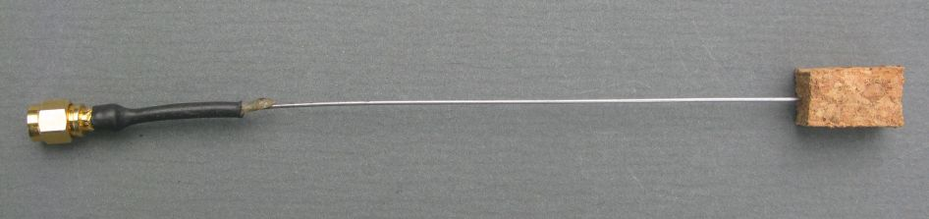
¼ Wave Wire Antenna
All you need now is a large grass field, around 150M across and a can or pole around 1.5M high. Load the transmitter with the test software and secure it to the pole with a bit of tape, see picture. In this case the transmitter test software has a start power of 10dBm and a finish power of 10dBm, meaning that it will only transmit a 10dBm packet. The LoRa modem settings are bandwidth 62.5khz, Spread Factor 12, Code rate 4:5. You can use either the short test packet or the longer packet which includes GPS sample co-ordinates. See the description of the test software at the end of this document for more details.
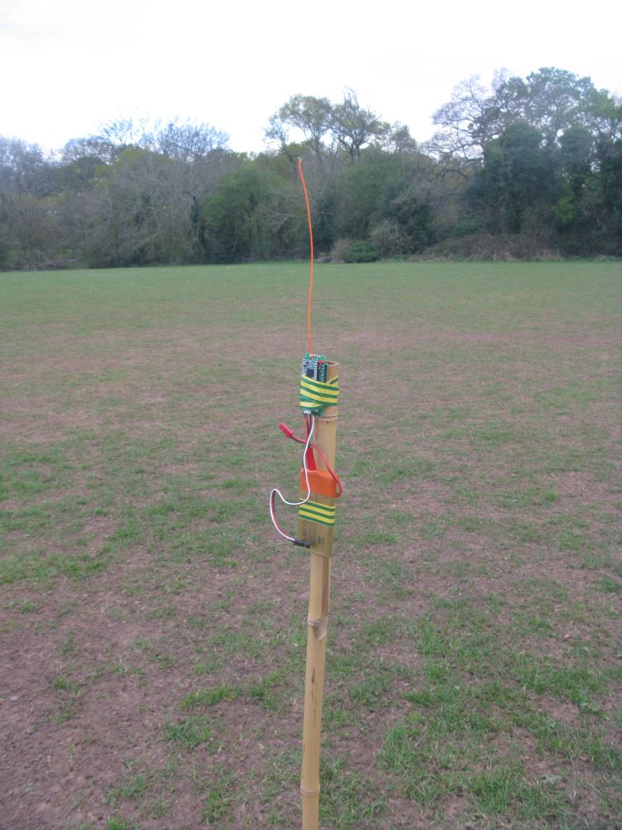

Transmitter on Pole

Make sure the transmitter antenna is vertical and straight. You can use a laptop with a serial monitor to view test results but it is a lot easier to use a receiver that has been built with a serial LCD connected as described in the instructions.

Walk 50M away from the transmitter and stand sideways to the transmitter so that your body does not act as a reflector and affect the readings.

The receiver will display on monitor and LCD the RSSI, Noise and SNR of the received packets.

Results at 50M for 10dBm (10mW) Transmitter Output Power

I tested two different transmitters, these were the results;

PIH LML 1 TX - Loose 1/4wave wire antenna RSSI -55dBm, Noise -97dBm, SNR +9dB
PIH LML 2 TX - Loose 1/4wave wire antenna RSSI -56dBm, Noise -94dBm, SNR +9dB

I had similar results with a transmitter fitted with a SMA socket and stiff ¼ wave wire antenna.
The Noise level is a background reading taken when there is no packet being received, it does initially display a very low reading, -137dB or so, but it settles down after a few loops.

For those that may have an RFExplorer, the RF carrier that is the audio tones sent by the test software was measured as -60dBm at 50M.

I confirmed the 10mW output power with the RFExplorer. With an attenuator connected to make sure you don’t blast the input of such a sensitive instrument, the RFExplorer can be used to measure the power output of the LoRa devices.

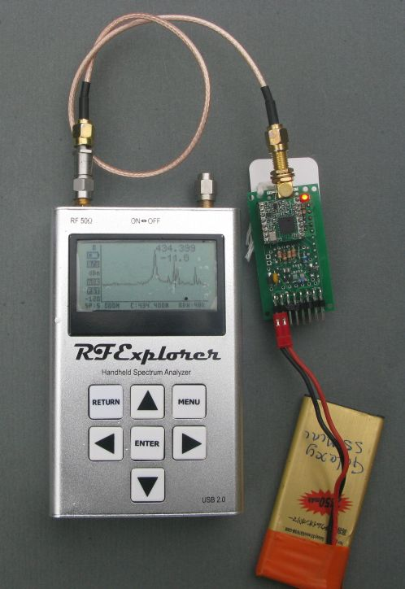

RFExplorer used to measure
Power

So there we have it. It should be an easy test for anyone to duplicate, and is a simple way of detecting failed modules. The LoRa modules are prone to damage if operated without an antenna, with these modules the received signal RSSI will be much lower than the -56dBm shown above, maybe in the region of -80dBm or so.

Weakest Received Signals
In a large open field you would need to walk a very long way from the transmitter before signals from the transmitter are so weak that reception is lost. However if you put the transmitter on the ground in an urban area or in a forest, there will be heavy attenuation of the signals and reception will likely fail at between 300M and 1000M from the transmitter. This is not meant to be a test as to what range you will get, that can vary greatly depending on the terrain, all we are doing is attenuating the signals so they are very weak. Walk away from the transmitter till the signals stop being received. The weakest signals received in my tests were;

RSSI -97dBm, Noise –99dBm, SNR –16dB
Expect some variation for your own setups. If there is a lot of RF noise around, the RSSI figure would likely increase as stronger signals are needed to overcome the noise level.
Descending Power Tests
In the tests described so far we have repeatedly transmitted only a single power packet, normally 10dBm.

The test software can be setup so that its starts at one power, sends a packet and tone, reduces the power by 1dBm then sends another tone. In this way you can have the transmitter send packets in sequence from 10dBm to 2dBm or even 17dBm to 2dBm if local regulations permit. The loop will continue forever and the start of the loop can be identified remotely by listening for the two start tones on a UHF handheld.

The descending power test can be used in a variety of ways. It can be used for an easy compare between different receiving antennas for instance. Setup the transmitter to transmit powers from 10dBm to 2dBm. Put the transmitter some distance away from the receiver, and monitor the serial monitor screen in the Arduino IDE for received packets.

The received packet has the dBm level used for transmit appended at the end, this is the output for the long lost model packet (8) and short test packet (T) both at 8dBm;

Long Packet 8*151.48230,-3.18136,25,8,
Short packet T*108

Assume that you receive all the packets down to 5dBm and not the lower power ones. You switch to a different receive antenna, and now you only receive the packets down to 8dBm. You then know that (approximately) the first antenna is 3dB better or has 3dB more gain than the second. You can use the same method to check the performance of different builds of receivers.

If when you run the test you receive all packets down to 2dBm, either move the transmitter further away or reduce the transmit power in some way. The easiest way to reduce power transmitted is to use attenuators on a transmitter that has a SMA socket fitted. These attenuators for SMA connectors are readily available, try eBay. Good values of attenuator to have handy are 10dB and 20dB. As an alternative you can cut the transmitted power significantly by fitting a 50ohm SMA terminator (dummy load) on the transmitter output. This can reduce range to a few 10s of metres, especially if the transmitter in put in a metal tin, which can be a useful testing strategy if you don’t have a lot of space.

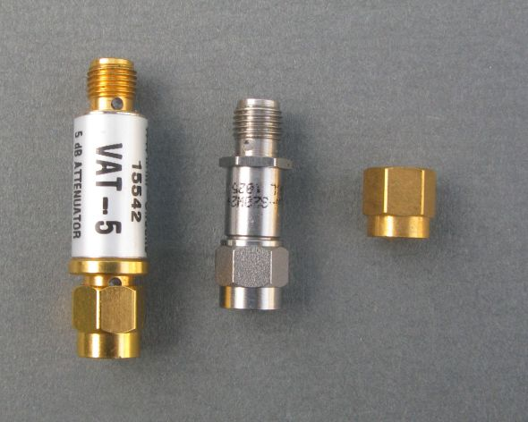

Two SMA attenuators
and a terminator

You can use the test software without a PC as a terminal, which can be handy if your on a remote mountain top. With a UHF handheld listen for the two start tones on a UHF handheld and count the LED flashes on the receiver indicating a packet received. If the transmitter starts at 10dBm and you count 5 flashes on the receiver, your picking up down to the 6dBm packet.

Test Software

The test software can transmit two types of packet;

LML Payload Packet

This is the same packet that the lost model locator software transmits, with the power level appended at the end. The latitude and Longitude can be set with the #defines at the start of the program. You can therefore use this test software with a GPS enabled receiver and have the transmitter simulate a remote tracker so that you can check the distance and direction calculation or mapping application.

Test Packet

This is a much shorter packet and is the standard addressing bytes (packettype, destination node source and source node followed by the power level in dBm as two ASCII bytes, it will display on the RX terminal as;

T*108

T= test packet
* = broadcast
1 = from node 1
08 = 8dBm

LoRa Parameters for testing

These are set in both the transmit and receive programs, here are the transmit settings, the LoRa Modem Parameters need to be the same for transmitter and receiver.

/******* Setup TX Test Parameters Here ! ***************
//LoRa Modem Parameters
const byte test_Bandwidth = lora_BW62_5; //LoRa bandwidth
const byte test_SpreadFactor = lora_SF8; //LoRa spreading factor
const byte test_CodeRate = lora_CR4_5; //LoRa coding rate
const byte test_RateOptimisation = lora_LowDoptOFF; //LoRa data rate optimisation
#define Latitude "51.48230" //GPS co-ordinates to use for test
#define Longitude "-3.18136"
#define Altitude "25"
const byte start_power = 10; //Start power for transmissions
const byte end_power = 2; //End power for transmissions
#define ThisNode '1'
//********************************************************

The full list of Bandwidth, Spreading Factor, Coding rates and data rate optimisation settings is found in lora.h, and reproduced here;

const byte lora_BW7_8 = 0; //7.8khz
const byte lora_BW10_4 = 16; //10.4khz
const byte lora_BW15_6 = 32; //15.6khz
const byte lora_BW20_8 = 48; //20.8khz
const byte lora_BW31_2 = 64; //31.2khz
const byte lora_BW41_7 = 80; //41.7khz
const byte lora_BW62_5 = 96; //62.5khz
const byte lora_BW125 = 112; //125khz
const byte lora_BW250 = 128; //250khz
const byte lora_BW500 = 144; //500khz
const byte lora_SF6 = 6;
const byte lora_SF7 = 7;
const byte lora_SF8 = 8;
const byte lora_SF9 = 9;
const byte lora_SF10 = 10;
const byte lora_SF11 = 11;
const byte lora_SF12 = 12;
const byte lora_CR4_5 = 2; //4:5
const byte lora_CR4_6 = 4; //4:6
const byte lora_CR4_7 = 6; //4:7
const byte lora_CR4_8 = 8; //4:8
const byte lora_Explicit = 0; //Use to set explicit header, for variable length packets
const byte lora_Implicit = 1; //Use to set implicit header
const byte lora_LowDoptON = 0x08; //value to turn low data rate optimisation on
const byte lora_LowDoptOFF = 0x00; //value to turn low data rate optimisation off

Notes:

If the symbol time is greater than 18mS then lora_LowDoptON needs to be used, the ‘Semtech LoRa Calculator’ can be used to work out the symbol time.

Only lora_Explicit is used in the test software, so that variable length packets can be used.

You cannot use lora_SF6 with lora_Explicit.

Stuart Robinson
GW7HPW
27th April 2016

